

**Automatic measurement of body flexion**

**with TFmini Plus**

# Auto-measuring Instrument For Body Flexion

## Application Background

Sit and reach (as shown in Figure 1.1) is a physical exercise program and a physical fitness test program for Chinese primary and secondary schools. Its purpose is to measure the possible range of motion of the trunk, waist, hip and other joints at rest, which mainly reflects the extensibility and elasticity of the joints, ligaments and muscles and the development level of the body's flexibility. Sit and reach is one of the compulsory items in the entrance examination of physical education in China.

.

Fig.1.1 Sit and reach

## Application

This system is an automatic measuring device designed and developed by using TFmini Plus, Arduino-UNO board, 0.91 inch OLED display module, BY8301-16P voice module, speaker and traditional sit and reach measuring instrument of Benewake (Beijing) Co. Ltd.

Function of the system: realize the automatic measurement of body flexion, display and broadcast the measurement results, reduce the process of artificial reading, and make the process of sports testing more intelligent and humane.

# Test Equipment and Wiring

## Test Equipment

* **Benewake TFmini Plus Standard Edition**

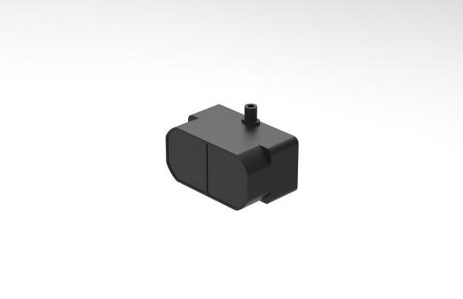

Fig.2.1 TFmini Plus

TFmini-Plus(as shown in Figure 2.1). For detailed parameters, please refer to the TFmini-Plus product manual.

* **Arduino-UNO Board**

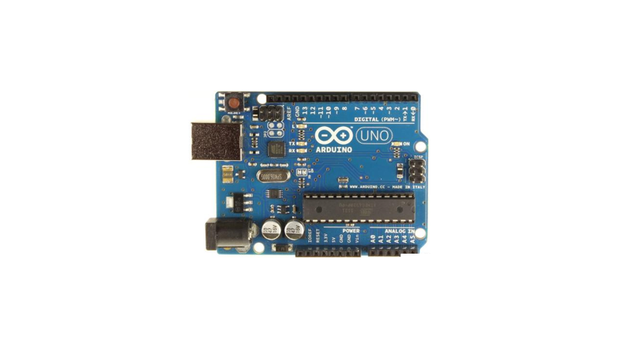

Fig.2.2 Arduino UNO

Arduino UNO board（as shown in Figure 2.2）. For a detailed introduction and study, please refer to the following two websites:

Chinese Community：<http://www.arduino.cn/>；

English Official Website：<http://www.arduino.cc/>。

* **0.91 Inch OLED LCD Display**

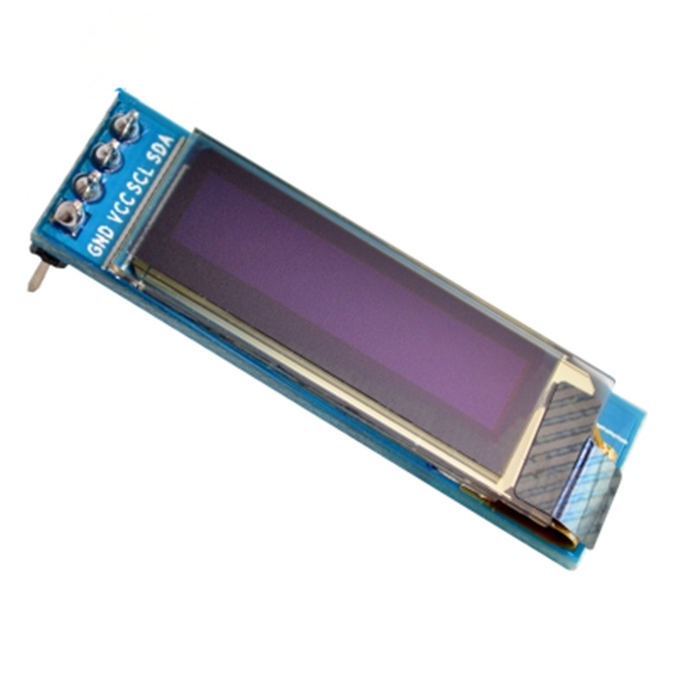

Fig.2.3 OLED display

Specifications: 0.91 inch OLED display (as shown in Figure 2.3), 128 * 32 dot matrix, IIC control interface, compatible with 3.3-5V.

Function: used to display the measurement results.

* **BY8301-16P Voice Module**

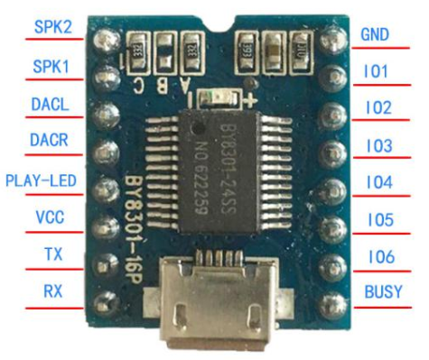

Fig.2.4 BY8301-16P voice module

Specifications: voice module (as shown in Figure 2.4), working voltage DC 3.6-5V, support MP3/WAV format, support UART serial communication control, comes with 3W amplifier / external power amplifier.

Function: used to control the speaker, broadcast prompt information and measurement results.

* **BY-90-1W Passive Speaker**

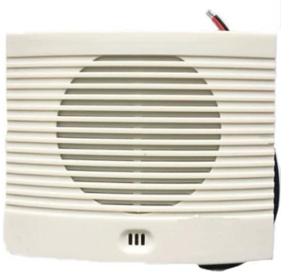

Fig.2.5 Passive speaker

Specification: Speaker (as shown in Figure 2.5), power is 8Ω1W.

Function: broadcast prompt information and measurement results.

* **Computer**

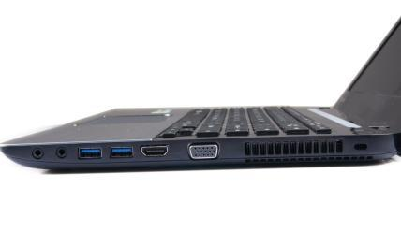

Fig.2.6 computer

As shown in Figure 2.6, as the host computer of the system, used to write and upload programs to the UNO board.

* **Traditional Measuring Instrument of Sit and Reach**

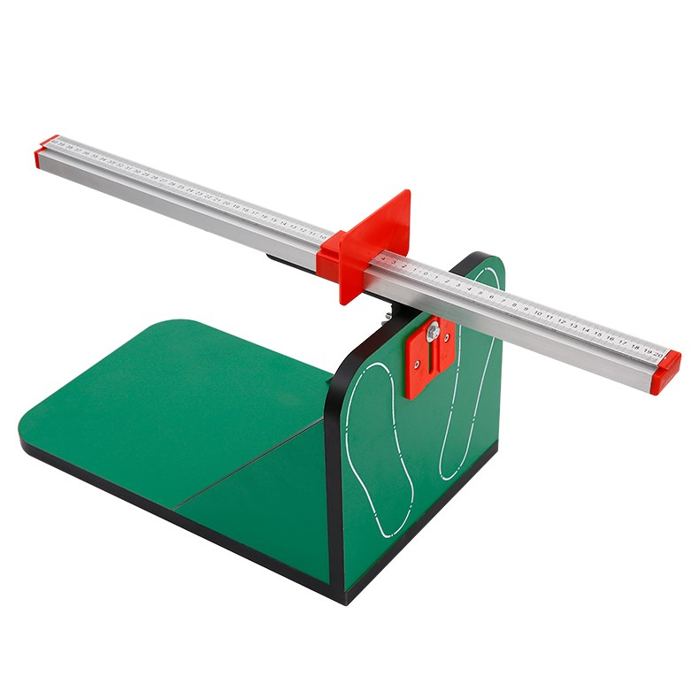

Fig.2.7 measuring instrument for body flexion

* **cable**

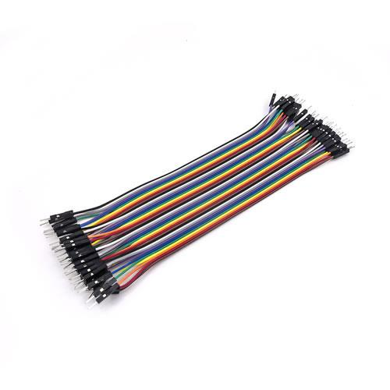 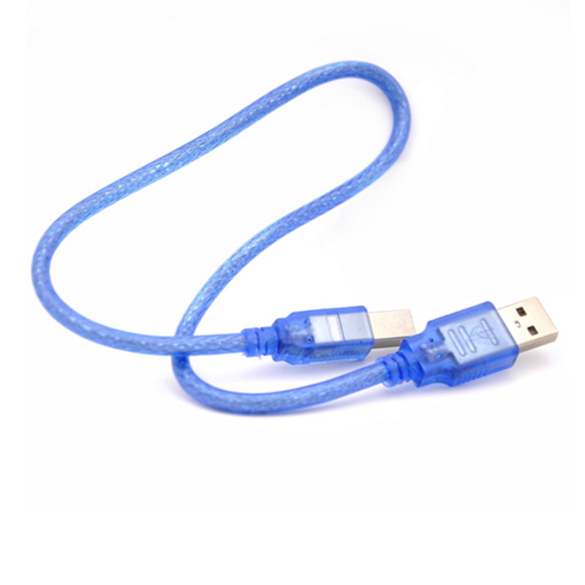

Fig.2.8 cable

DuPont line – used for Plus and UNO board connection;

USB square port data cable - used for UNO board and computer connection and power supply.

## Wiring

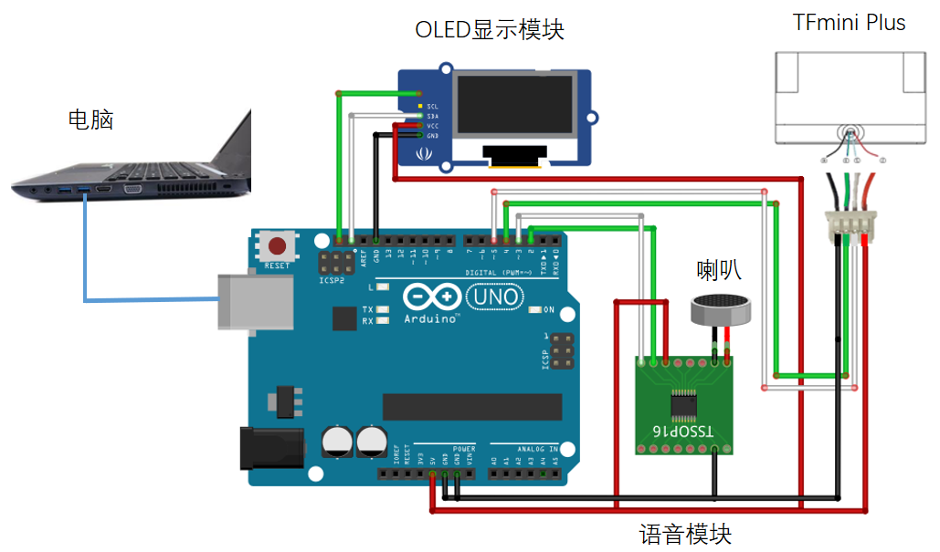

Fig.2.9 System wiring

* TFmini Plus line order：

|  |  |  |  |  |
| --- | --- | --- | --- | --- |
| No. | Color | Corresponding PIN | Function | Comment |
| ① | Red | PIN-1 | +5V | Power supply |
| ② | White | PIN-2 | RXD/SDA | Receiving/Data |
| ③ | Blue/Green | PIN-3 | TXD/SCL/IO | Transmitting/Clock/IO |
| ④ | Black | PIN-4 | GND | Ground |

Fig.2.10 TFmini Plus line order

TFmini Plus power supply voltage is 5V, directly connected to 5V and GND of Arduino board. Other radars need to consult product datasheet to ensure normal power supply.

* For the Arduino UNO board, the serial communication connection needs to pay attention to:

1. The TX terminal of TFmini Plus is connected to pin 4 ports of the board (RX of soft serial port Serial 2), and the RX terminal of radar is connected to pin 5 ports of the board (TX of soft serial port Serial 2).
2. The voice module is connected to 5V and GND of UNO board, the TX terminal is connected to pin 2 of board (RX of Serial 1 of soft serial port), and the RX terminal of radar is connected to pin 3 of board (TX of Serial 1 of soft serial port), Soft serial port 1 is defined in voice library. The voice module can only connect 2 or 3 pins of UNO board in sequence, Otherwise, voice library files must be modified (supporting setting volume 0-20).

* 0.91-inch OLED display connects 5V (or 3.3V) and GND power supply, SCL and SDA connect UNO board SCL and SDA.

# Principle of automatic measurement of body flexion

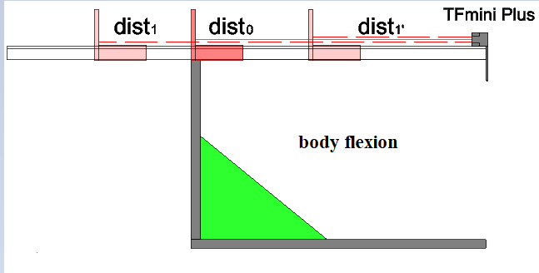

Fig.3.1 Automatic measurement system for body flexion

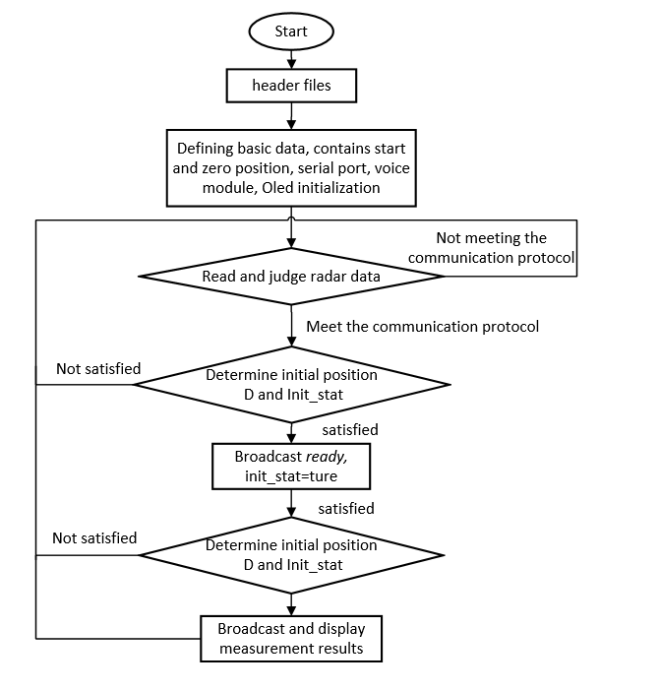

Fig.3.2 Flow chart of working principle for automatic measurement of body flexion

As shown in Fig. 3.1 and Fig. 3.2, the system diagram and working principle flowchart of the automatic measurement of body flexion are presented respectively.

Firstly, we include voice and OLED library files, define variables, initialize serial port, voice module and OLED display screen, read radar data, calibrate the system, and get start = dist1, zero = dist0;

Then, read the data, judge the position initialization state init_stat and the relationship between the radar data and start. If the requirements are not met, obtain the data and make a judgment again. If the requirements are met（!init_stat（not initialized） && D==start（the radar data is equal to the initial position of the calibration）），the voice module broadcasts "ready" and starts measuring;

During the measurement process, continue to judge the position initialization state init_stat and the relationship between radar data and start. If the requirements are not met, obtain the data and make a judgment again. If the requirements are met（!init_stat（initial position completed） && D==start（the baffle leaves the initial position）），Check whether the baffle moves at any time. If the baffle is stationary, it will go through about 2.3s, the system ranging is stable, and the measurement results are broadcasted and displayed;

Finally, determine if the next test is needed. if not, power down, and end the test.

# System Programming

This routine requires adding OLED libraries and custom libraries voice and oled.

0.91OLED library files：



voice library files：



oled library files：



procedure annex：



##include "voice.h"

#include "oled.h"

#include<SoftwareSerial.h>//head file of soft serial port

SoftwareSerial Serial2(4,5); // Define the soft serial port name as Serial2, and set pin2 as RX and pin3 as TX.

/* For an arduino board with multiple serial ports, such as the DUE board, comment out the above two pieces of code and use the Serial1 serial port directly*/

/* Radar basic data */

int check;// Check value storage

int uart[9];// Storage of radar measurements

int k;

const int HEADER=0x59;//Packet header

/* Automatic measurement data of body flexion */

int D;// Range measured by Radar

int d=0;// Last distance

int result=0;

const int zero=40;// Calibrated 0 point, calibration setting is required after installation

int VAR[23]={0};

int var;

int num=0;

const int start=54;// Calibration starting point, calibration setting is required after installation

int CHA[15]={0};

int cha=0;

int count=0;

boolean init_stat=false;// Determine whether location initialization is performed

void setup()

{

Serial.begin(115200);// Set the baud rate of the arduino uno to the serial port of the computer.

Serial2.begin(115200);

oled_begin();//OLED display module initialization

voice_begin();//Voice module initialization

voice_setvolume(14);//Set the speaker volume

}

void loop()

{

Serial2.listen();

if (Serial2.available())//Check whether the serial port has data input

{

if(Serial2.read()==HEADER)

{

uart[0]=HEADER;

if(Serial2.read()==HEADER)

{

uart[1]=HEADER;

for(k=2;k<9;k++)// Storing data into an array

{

uart[k]=Serial2.read();

}

check=uart[0]+uart[1]+uart[2]+uart[3]+uart[4]+uart[5]+uart[6]+uart[7];

if(uart[8]==(check&0xff))// Verify the received data according to the protocol

{

D=uart[2]+uart[3]*256;// Calculate the distance

if(!init_stat && D==start)

{

cha=D-start;

for(k=15;k>=1;k--)

{

CHA[k]=CHA[k-1];

}

CHA[0] = cha;

for(k=0;k<15;k++)

{

if(CHA[k]==0)

{

count++;

}

}

oled_measuring();

if(count>=15)

{

voice_ready();

init_stat=true;

}

}

if(D!=0 && D!=start && init_stat)

{

var=abs(D-d);

for(k=23;k>=1;k--)

{

VAR[k]=VAR[k-1];

}

VAR[0] = var;

for(k=0;k<23;k++)

{

if(VAR[k]==0)

{

num++;

}

}

if(num>=23)

{

result=zero-D;

oled_result(result);

voice_num(result);

Serial2.listen();

init_stat=false;

}

d=D;

num=0;

}

}

}

}

}

}

# System Work and Data Viewing

## Workflow Diagram



Fig.5.1 System workflow diagram

* After the system is installed, power supply, upload program, calibration starting point and 0 position；
* The baffle is placed at the starting point, and after the voice module broadcasts "ready", measurement begins；
* After the baffle leaves the starting point, it cannot be paused for a long time, generally within 2.3s. When the baffle is stationary and stable measurement is performed, the measurement results are displayed in the OLED.。

## Data Viewing

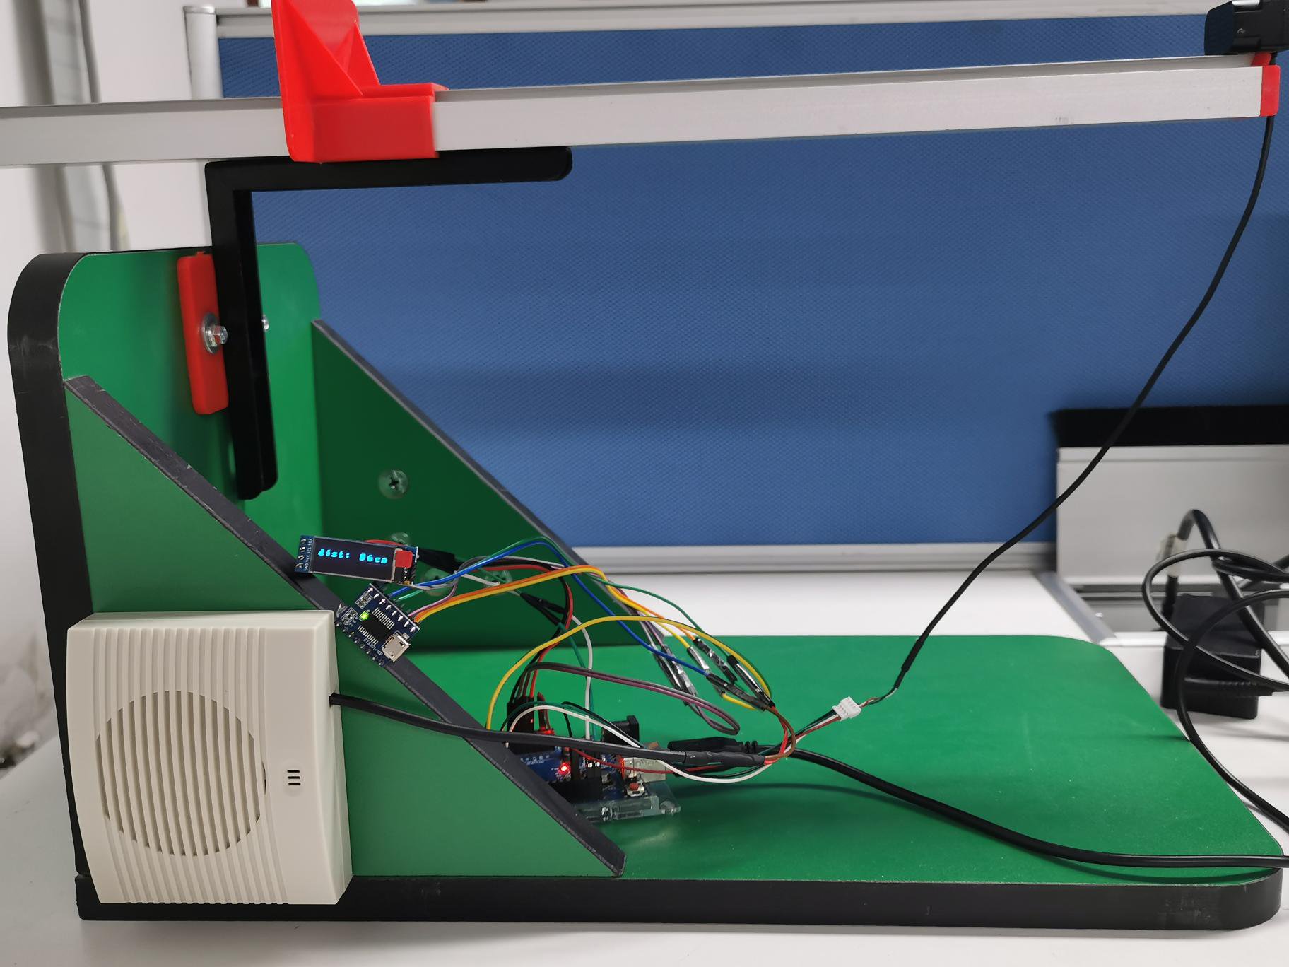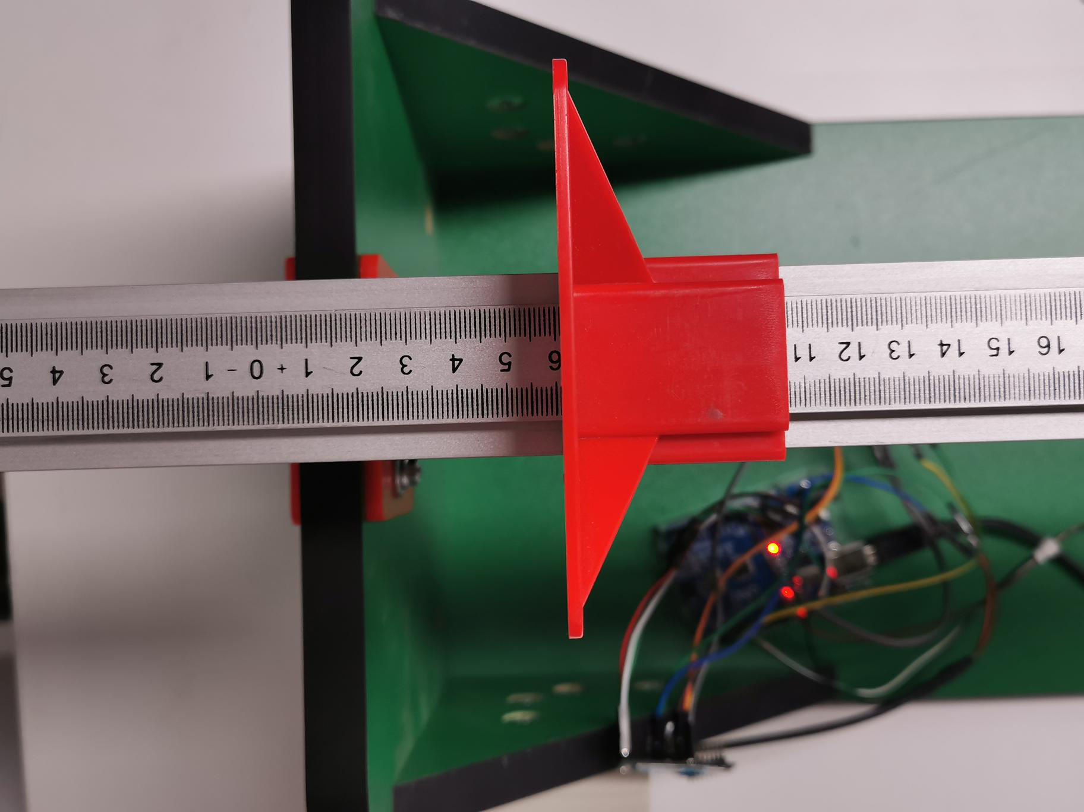

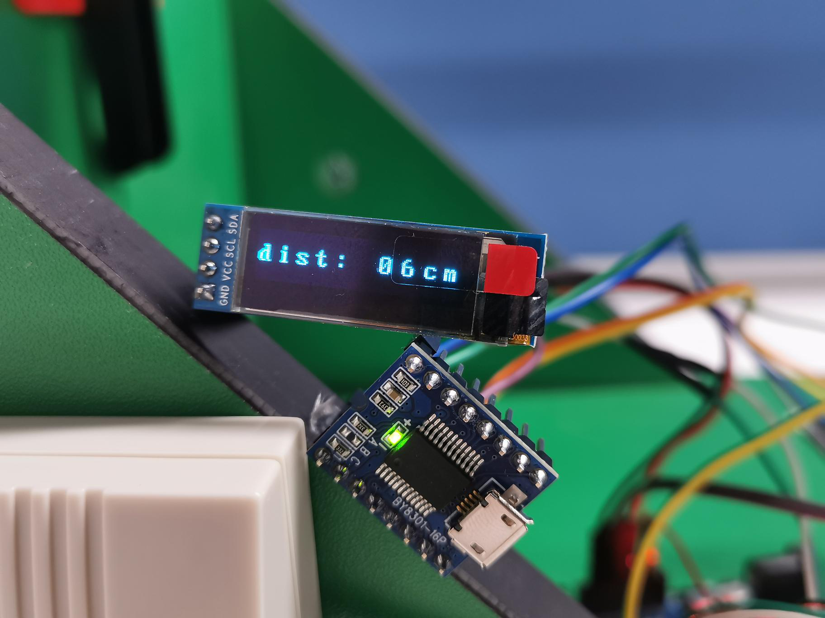

Fig.5.2 Work data

# Cautions

* The measurement resolution of the TFmini Plus is 5mm. If the measurement accuracy is mm, there will be a large error, so only the cm can be measured, and the mm-level measurement can be realized with a higher precision product.
* The auto-measuring instrument for body flexion will not broadcast during the measurement process, but it cannot be stopped for a long time (less than 2.3s).
* The system is one test at a time, and after the measurement is completed, it needs to be re-homed to the starting point.